 

Brigham Young University – University of Zacatecas Collaboration 2008

Hydrologic Study of the “Zona Sur” Watershed

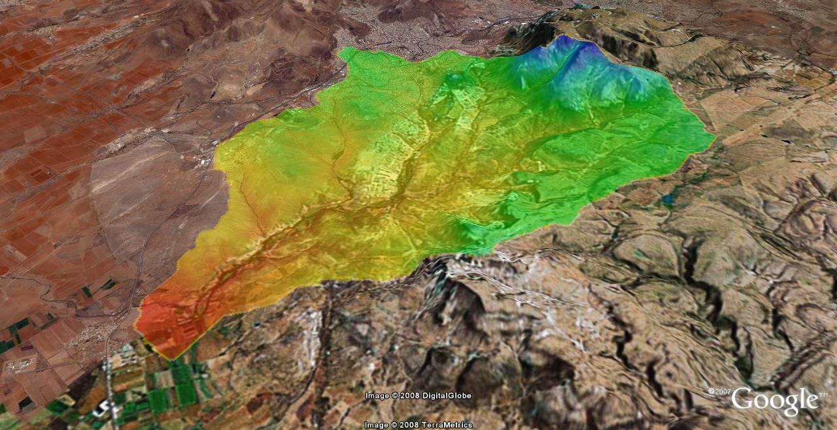

Team Members:

Kyle Robe

Cameron Jenkins

Jessica Merrell

Clinton Merrell

Brigham Young University

Provo, Utah 84602

April 15, 2008

**Table of Contents**

Summary 3

Introduction 4

Materials and Methods 4

Pre-Collector Model 6

Post-Collector Model 7

Results and Discussion 9

Conclusions 12

Appendix 15

Project Data Guide 16

**List of Figures**

Figure 1. Incremental distribution of the 3-hour design storm. 6

Figure 2. Zona Sur model without the new storm water collector. 7

Figure 3. Zona Sur model with the new storm water collector. 8

Figure 4. Total outflow hydrographs for pre- and post collector models. 9

Figure 5. Hydrographs for each outlet in post-collector model 11

**List of Tables**

Table 1. Parameters for Muskingum-Cunge River Routing 9

Table 2. Comparison of Peak Discharge of the Two Basin Models 10

Table 3. Peak Discharge for Each Sub-basin in Post-Collector Model 11

# Summary

Due to increasing urbanization in the city of Zacatecas in Zacatecas, Mexico, there is a growing concern that the resulting increase in runoff will create problems due to flooding. The primary watershed impacted by this urbanization is the Zona Sur Basin. A storm water collector has been constructed in this basin in an effort to mitigate potential flooding. However, hydrologic studies were needed to determine the effectiveness of the collector in handling the increased runoff and lowering the risk of flooding. This preliminary study was performed with data from the climatological station, La Bufa, and used SCS methods in WMS to create two different models which represent the watershed both with and without the collector. The pre-collector model considered the entire basin as a whole, whereas the post-collector model considered the basin divided into three sub basins. From these two models, hydrographs were created to determine the peak discharge both with and without the collector. Due to the differences in the way the basin was considered for these two models, the results obtained indicated a higher peak discharge for the post-collector model than the pre-collector model. Additional studies are needed to more accurately assess the impact of the collector and the potential for flooding in the Zona Sur Basin.

# Introduction

The city of Zacatecas in Zacatecas, Mexico has recently experienced a large amount of urban development and expects to experience much more in the coming years. As the city grows, city planners and engineers are afraid that the increase in urban development will cause an increase in storm water runoff. Much of this new development is planned for an area designated as the Zona Sur watershed. This watershed encompasses 17 squares miles of the southern frontier of the city. Already, there are problems with storm-related flooding in some areas of the Zona Sur watershed. At the start of this project, the goal was to determine what increase, if any, would occur in the peak watershed discharge and total volume of runoff after the currently planned development was completed.

Upon arriving in Zacatecas, however, we learned that a simple storm water collector had already been constructed in an attempt to alleviate the flooding problems. Rather than perform a pre- and post-development model as we had planned, we decided to develop two models, one which attempted to simulate the watershed response before the storm drain collector had been built and another to simulate the response after the collector had been built. Using the results of these two models, we hoped to understand what impact the collector had on the flooding in the watershed.

# Materials and Methods

Watershed Modeling System (WMS) was used in conjunction with HEC-HMS to develop the two models used in this study. To begin, a 90m resolution Digital Elevation Model (DEM) was use to define the topography of the watershed, delineate its boundaries and define its drainage network. In order to represent the spatial variability of the soil types and land uses present within watershed, scanned images of soil type and land use maps were obtained, registered and digitized manually in WMS. Originally, a separate coverage for the future land use was also developed using CAD drawings obtained from the group in Zacatecas. This coverage was not used in our simulation as we changed the objectives of our project slightly. Instead, only the present land use conditions were considered. In addition to the land use maps, aerial photographs were also used to define the spatial distribution of land use.

After creating soil type and land use coverages in WMS, the meteorological parameters for the study were determined. The Zacatecas group developed intensity-duration-frequency tables using the data from the surrounding climatological stations. The two stations closest to the Zacatecas watershed are designated as La Bufa and Zacatecas. The IDF tables are included in the Appendix for reference. The historical record for these two stations did not encompass the same time period, so the rainfall intensities obtained from the two IDF curves were not similar; the intensities from the Zacatecas station were about five times larger than those from the La Bufa station. Based on the experience of the students in Zacatecas, the lower intensities from La Bufa were seen as more representative of the current climatological conditions, and only data from this station was used rather than weighting the intensities from both stations. For the models, a total rainfall depth of 1.6 inches for a 20-yr, 24-hr duration storm was used to create a 3-hour storm in an attempt to better represent a typical storm in that area. The 3-hour distribution is shown below in Figure 1.

Figure . Incremental distribution of the 3-hour design storm.

After determining the design storm, the two models were developed and are discussed separately below.

## Pre-Collector Model

For simplicity, the pre-collector model consisted of a single basin with no sub basins. Losses and overland flow transformation were both simulated using the SCS methods. The soil type and present land use coverages were used to determine a single, composite curve number for the entire basin. This curve number was 79.7. This is a relatively high curve number and is the result of the soil types found in the basin. Based on our site visits, we determined that the basin consisted of mostly hydrologic soil types C and D which experience relatively low amount of infiltration. Much of the basin was urban as well, contributing to the high curve number. The initial abstraction for this model was determined using the equation:

$I_{a}= 0.2\left(\frac{1000}{CN}- 10\right)$

Where:

*Ia=* initial abstraction in inches

CN = the basin curve number

For transformation of the overland flow, the SCS synthetic hydrograph was used and the lag time for the watershed response was calculated using the SCS equation. The pre-collector model is shown in Figure 2 below.

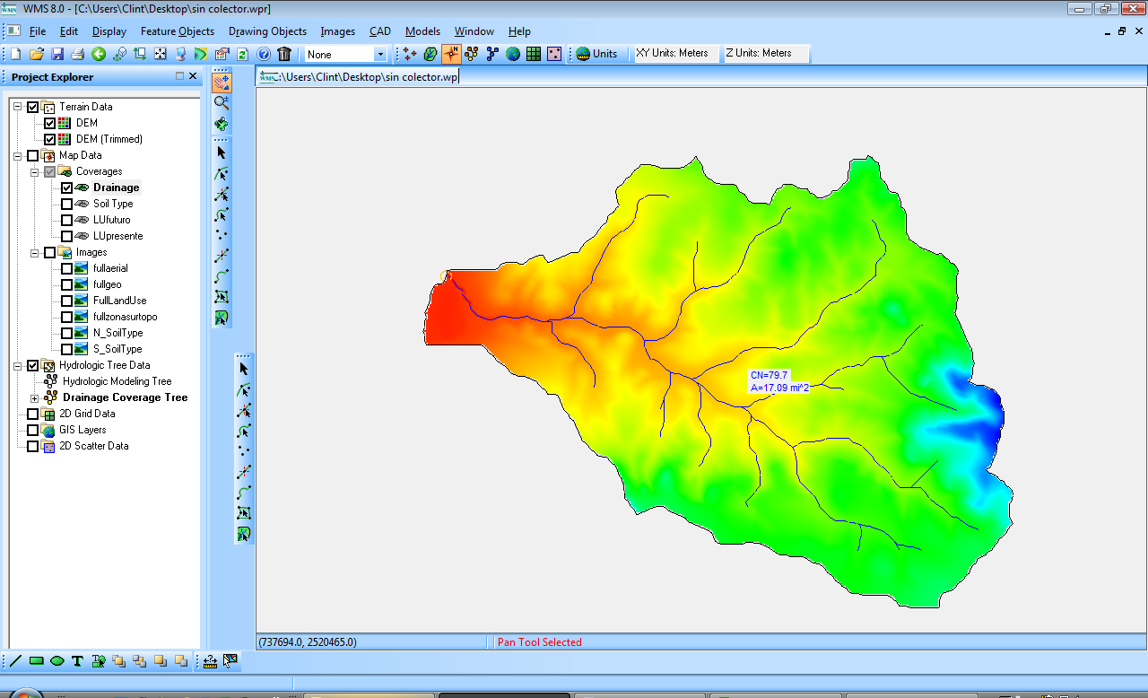

Figure . Zona Sur model without the new storm water collector.

## Post-Collector Model

Again the SCS methods for determining losses and transformation were used. For this model, the basin was sub divided into three sub-basins. One basin included all of the area which drained to the collector, seen in the top right of Figure 3 below. The collector runs through the basin on the bottom left of Figure 3 and exits at a water treatment plant located on the west side of that same basin. We assumed that no runoff enters the collector between its inlet and outlet. After exiting the collector, the runoff travels through a natural trapezoidal channel to the outlet. For determining losses, curve numbers were computed for each sub-basin individually. These curve numbers are also shown in Figure 3.

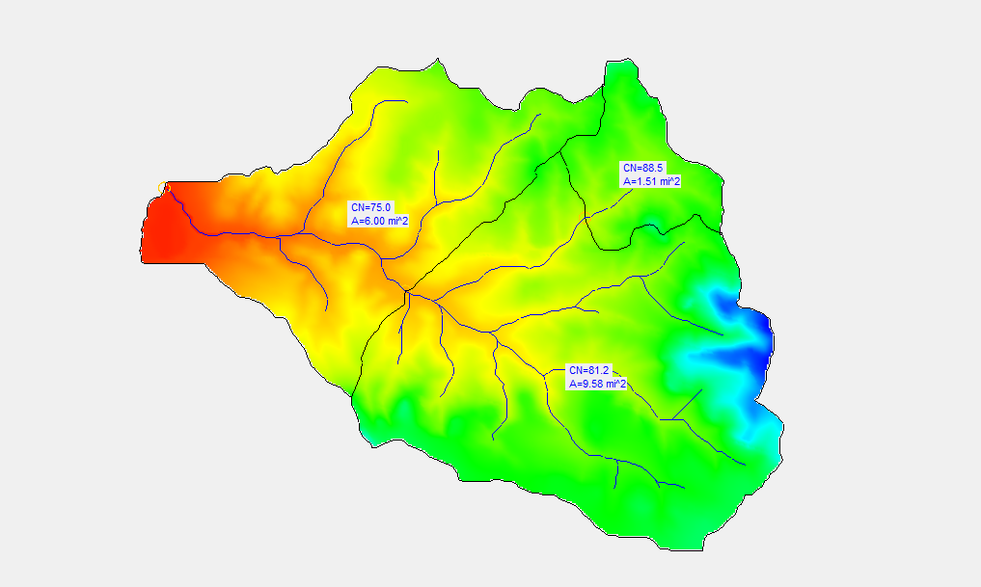

Figure . Zona Sur model with the new storm water collector.

In order to model the collector and natural channel, the outflow hydrograph from the northeast basin had to be routed from the outlet of that basin to the outlet of the middle basin. Then, the routed hydrograph was combined with the overland flow from the middle basin and the resulting hydrograph was routed to the outlet of the entire basin. Routing was performed using the Muskingum-Cunge Standard method. For this method, the channel geometries had to be estimated. The collector in reality is rectangular with an arched roof but we had to approximate it as simply rectangular for modeling purposes. The natural channel was approximated as trapezoidal. Table 1 below shows a summary of the parameters used for the Muskingum-Cunge method.

Table . Parameters for Muskingum-Cunge River Routing

|  |  |  |
| --- | --- | --- |
|  | Collector | Natural Channel |
| Length (ft) | 10886 | 14988 |
| Slope (ft/ft) | 0.0185 | 0.0135 |
| Manning's n | 0.02 | 0.04 |
| Shape | Rectangular | Trapezoidal |
| Width/Bottom width (ft) | 9 | 10 |
| Side Slope | - | 0.5:1 |

# Results and Discussion

Both models were run in HEC-HMS using the parameters and methods described above and outflow hydrographs were obtained for both models. The resulting hydrographs are shown below in Figure 4.

Figure . Total outflow hydrographs for pre- and post collector models.

The peak discharge for each of the models was also tabulated and is shown in Table 2 below.

Table . Comparison of Peak Discharge of the Two Basin Models

|  |  |  |
| --- | --- | --- |
|  | Post-collector | Pre-collector |
| Q max (cfs) | 1301.4 | 1701.9 |
| Q max (l/s) | 36829.62 | 48163.77 |

Both models resulted in approximately the same volume of runoff but surprisingly, the peak discharge for the post-collector model was higher than that of the pre-collector model. This is probably because by splitting the watershed into three sub-basins and calculating a curve number for each basin, the model better represented the spatial variability of the land use within the basin. In the pre-collector model, a large area of rural land use with a low curve number was lumped together and averaged with a smaller area of urban land use with a higher curve number. This resulted in a lower composite curve number for the basin. In the post-collector model, that same rural area was mostly located in one sub-basin and the urban area in another. In that situation, the curve number for the urban areas was higher and more runoff developed and entered the collector, increasing the discharge for the entire basin relative to the pre-collector model. If another model was developed without the collector but subdivided into three basins in the same way as the post-collector model, the two peak discharges would be nearer to each other.

The hydrograph for the post-collector model also peaked earlier than the pre-collector model. This is due to the channelization of the water in the collector and the natural channel. In the pre-collector model, the runoff is basically all treated as if it were overland flow. Since water generally moves more quickly channelized than it does flowing overland, the collector model peak discharge occurs more rapidly and discharge ceases more rapidly as well.

When the post-collector model was run, three different hydrographs were developed for each of the three sub-basins. These three hydrographs are shown below in Figure 5.

Figure . Hydrographs for each outlet in post-collector model

The peak discharges for each of the three sub-basins were also tabulated and are shown below in Table 3.

Table . Peak Discharge for Each Sub-basin in Post-Collector Model

|  |  |  |  |
| --- | --- | --- | --- |
|  | Collector inlet | Plant | Basin Outlet |
| Q max (cfs) | 540.3 | 1516 | 1701.9 |
| Q max (l/s) | 15290.49 | 42902.8 | 48163.77 |

These results are what we expected to see. The sub-basin contributing to the flow into the collector is small relative to the other sub-basins and thus its outflow hydrograph is smaller than the rest. The hydrograph at the treatment plant is the sum of the hydrograph from overland flow in the middle sub-basin and the hydrograph from the smaller sub-basin, routed though the collector. Thus the volume is progressively larger and the peak is lagged relative to the hydrograph at the collector inlet. The largest and final hydrograph is the sum of the hydrographs for all three basins. In other words, flow from the treatment plant was routed through the natural channel and then added to the overland flow from the western sub-basin.

These results demonstrate what amount of discharge should be expected at the water treatment plant now that the collector is built, but our analysis does not tell us what the discharge near the treatment plant was before the collector was built. In order to complete this analysis, another model of the pre-collector basin should be constructed with three sub-basins similar to the post-collector model, routing flow between sub basins by natural channels only. By doing this, not only would the curve numbers for both models be similar, but a hydrograph would be obtained at the location of the treatment plant. This hydrograph would depict pre-collector discharge which could then be reasonably compared to the results already obtained from the post-collector model. Building and running such a model would be a good practice exercise for the students in Zacatecas.

# Conclusions

This analysis provided a great practice in using WMS and HMS to develop working models but at the same time, the results of those models are still underdeveloped. It is impossible to state definitively that the models as currently constructed accurately simulate the response and behavior of the Zona Sur watershed. Now that basic models have been developed, those models need to be calibrated or “fine-tuned” using more watershed data and most importantly, observed discharge data. The following are a couple of steps that could be taken to improve the results of this analysis:

1. **Obtain better soil property data** – The SCS curve number method is empirical and does not model the actual physical process of infiltration. The Green and Ampt method of determining infiltration is more physics based but requires that soil properties be determined more carefully. This method requires knowledge of a watershed’s different soil properties such as hydraulic conductivity, porosity, saturation, and capillary head.
2. **Obtain channel cross sections** – With measured (surveyed) stream cross sections, and a given flow (obtained by the model), a corresponding normal depth for the stream can be determined and WMS can be used to perform simple floodplain delineations. This would indicate which structures are in danger of flooding given different precipitation events.
3. **Observed watershed discharge data** – Knowing the actual discharge hydrograph produced from a past storm can be used as a comparison or calibration standard for these models. The actual precipitation distribution for a known outflow hydrograph can be input into the model and the resulting hydrograph can be compared with the actual hydrograph for that storm. Ideally the hydrograph from the model would be the same as the actual hydrograph. If the model does not produce a similar hydrograph the parameters and methods used within the model can be changed and altered so that the model better matches real conditions. In the absence of observed data, measured cross sections could be used with a firsthand knowledge of stream depths resulting from a typical storm, and input into Manning’s equation to determine corresponding flow rates to provide a reasonableness check for the model results. If the model results are just too high or too low compared to personal experience, the model can be changed until results seem reasonable to someone from the area being modeled.
4. **Use a different model altogether** – Perhaps in this case, using the SCS curve number method in an HMS model was not the best choice. There are many other models and methods available such as GSSHA and MODClark. (A few examples of these other models applied to the Zona Sur basin, developed for a separate analysis, are included with the data for this analysis on the “ZonaSur_2008” in the folder titled “531_project”).

In conclusion, the analysis of the Zona Sur watershed performed as part of the 2008 collaboration between BYU and UAZ serves a starting point and learning tool for the development of better and more accurate models. The students who participated in developing these models should now have a better understanding of the methods and procedures involved in developing models and can use that knowledge to modify and calibrate these models to better address the original concerns of flooding in the area surrounding the city of Zacatecas, Mexico.

# Appendix

## Project Data Guide

The ZonaSur_2008 CD contains all of the data obtained and developed during the project. The following is an index explaining the folders and their contents.

**531_project –** contains the WMS, HMS, and GSSHA files used to develop additional models of the Zona Sur watershed for Dr. Nelsons Hydrologic modeling class. The following models were developed: HMS using SCS curve number method, HMS using Green and Ampt Method, HMS using MODClark method (problems were encountered using a user rainfall distribution), and GSSHA models using Green and Ampt method with and without stream flow.

**Communication –** Contains the emails, memos, and schedules exchanged over the course of the project.

**Datos Originales –** Original compressed files received from Zacatecas student. Files are in the compressed archive format, *.rar, and require a program such as WinRAR to extract them.

**DEM –** “DEM zona sur_datos.txt” is the metadata for the “zona_sur_original.asc” DEM file. The “zonasur_UTMNAD27.asc” DEM file is a transformation of the “zona_sur_original.asc” file into the UTM NAD 27 coordinate system.

**DWG –** Contains AutoCAD files from Zacatecas students used to determine location of collectors and extent of future development.

**HMS –** Contains the HMS files for the 2 models run, “sin_colector” and “con_colector”

**Imagenes –** “Fotografias_Aereas” contains aerial photos of the water shed with their associated world files. “Fotos” contains photos of the site, and Zacatecas students, sent by Professor Dzul prior to our visit. “Full_Maps” contains the soil type, land use, geologic and topographic maps pieced together in Photoshop, and their respective world files.”Legends” contains images of the legends of the four maps mentioned above. “North_maps” and “South_maps” contain the 4 maps mentioned above as they were received from the Zacatecas group, separated into maps of the north area of the city and the south area of the city. World files are also included. Metadata contains the coordinate system information for the maps.

**Presentacion –** contains the results of the two model runs as well as the PowerPoint presentation presented while in Zacatecas.

**Miscellaneous files –** “Estaciones cuencas” contains IDF tables for the climatological stations surrounding the city. The station for “La Bufa” was used for this project. “Objetivos” is a document from Professor Dzul which attempts to define the objectives of the project more clearly. “Soil Reference manual” is a document we attempted to use to decipher the soil type map. “tablausosuelo” is the curve number table used to generate basin curve numbers in WMS.



